**Mario Craft**

**Student:** Suki Tsz Ki Chan

**Group:**  Group GD2

**Submission Date: 08/12/2016**

Table of Contents

**Introduction:** 3

**Tools Used:** 4

**GitHub:** 4

**Main Menu Form:** 4

**Register Form:** 8

**Conclusion:** 11

**References:** 11

# **Introduction**

This is an individual project continuing from phase 1 and phase 2 of the project. In this phase of the project, I am to implement MarioCraft by creating a graphical user interface. The language I will use to code is C#.

Main Menu UI

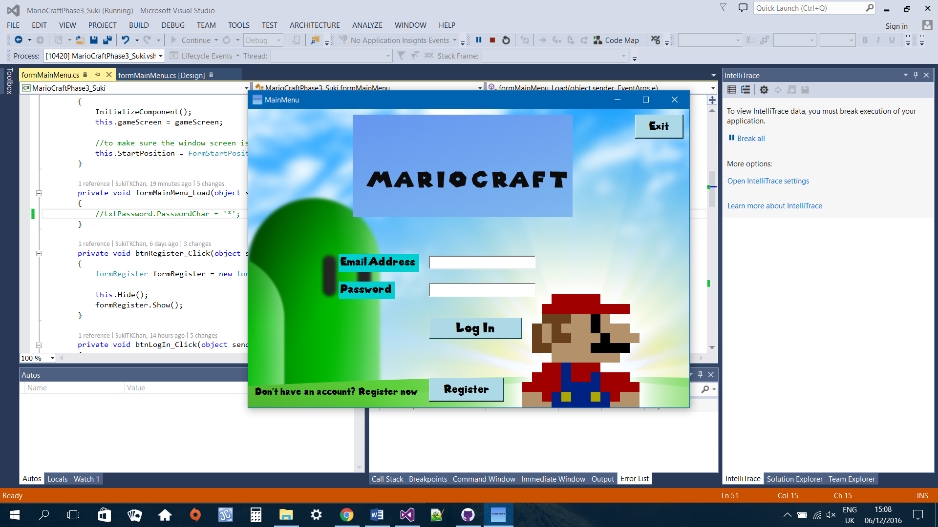

Register Menu

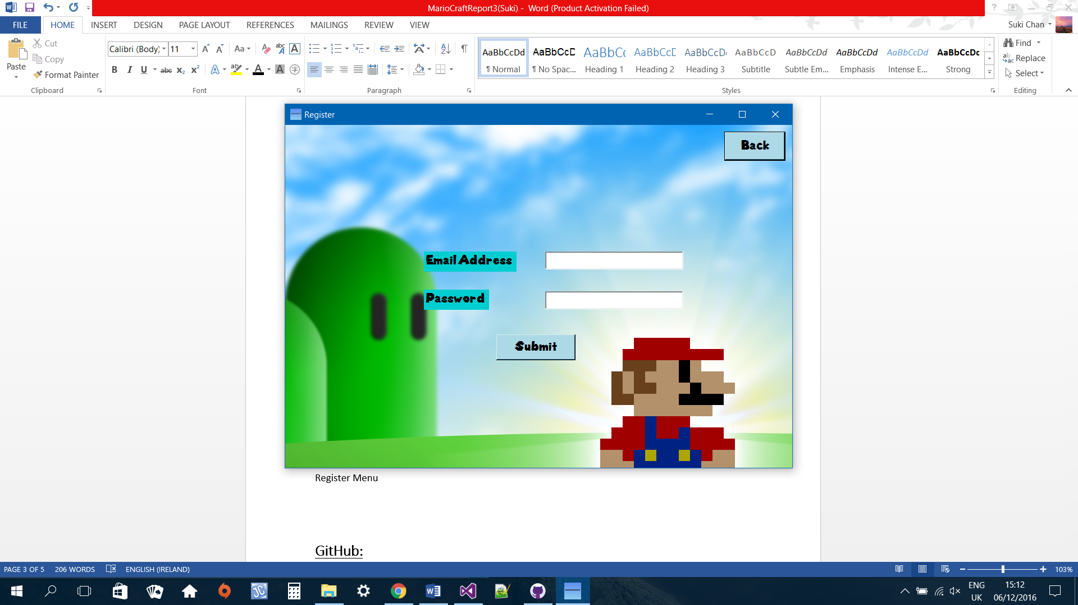

Game Screen – only a very basic design

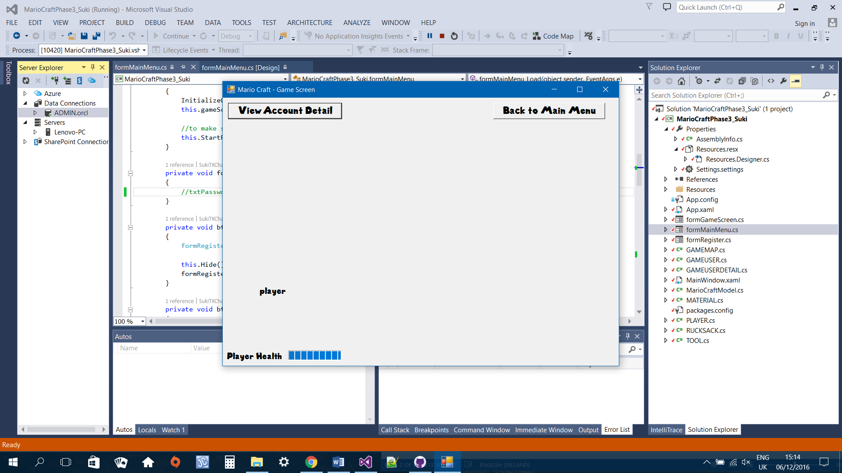

# **Tools Used**

Visual Studio 2013

Entity Framework

GitHub: <https://github.com/SukiTKChan/MarioCraftPhase3>

# **GitHub**

I am using GitHub for version control. I find this convenient and efficient as I can keep track what changes I have made.

Screenshot of commit messages

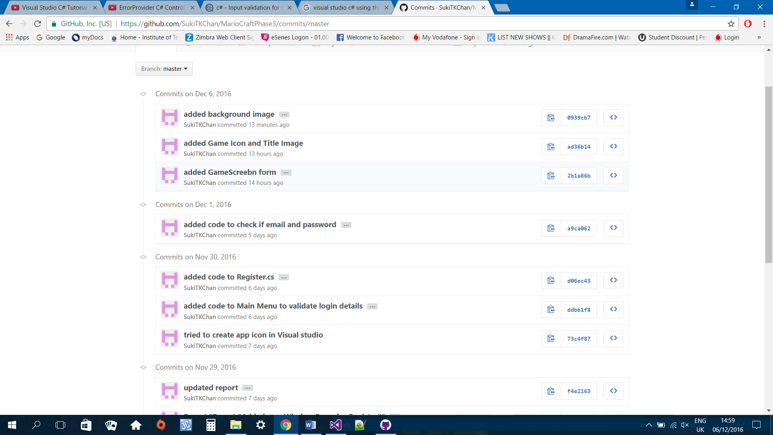

# **Main Menu Form**

The main menu form is the first screen that will display when the program runs. Every game user must either log in or register an account in order to play. If the game user does not have an account, he/she will need to click on the register button and the register menu will display. Otherwise, the user will need to enter an email address and password. The system will then validate to make sure the email and password input matches database.

Code:

using System;

using System.Collections.Generic;

using System.ComponentModel;

using System.Data;

using System.Drawing;

using System.Linq;

using System.Text;

using System.Threading.Tasks;

using System.Windows.Forms;

using System.Data.OracleClient;

namespace MarioCraftPhase3_Suki

{

public partial class formMainMenu : Form

{

private formRegister registerMenu;

private formGameScreen gameScreen;

GAMEUSER gameUser = new GAMEUSER();

public formMainMenu()

{

InitializeComponent();

//to make sure the window screen is display at centre

this.StartPosition = FormStartPosition.CenterScreen;

}

public formMainMenu(formRegister registerMenu)

{

InitializeComponent();

this.registerMenu = registerMenu;

//to make sure the window screen is display at centre

this.StartPosition = FormStartPosition.CenterScreen;

}

public formMainMenu(formGameScreen gameScreen)

{

InitializeComponent();

this.gameScreen = gameScreen;

//to make sure the window screen is display at centre

this.StartPosition = FormStartPosition.CenterScreen;

}

private void formMainMenu_Load(object sender, EventArgs e)

{

//txtPassword.PasswordChar = '*';

}

private void btnRegister_Click(object sender, EventArgs e)

{

formRegister formRegister = new formRegister(this);

this.Hide();

formRegister.Show();

}

private void btnLogIn_Click(object sender, EventArgs e)

{

MarioCraftModel ctx = new MarioCraftModel();

//gameUser = ctx.GAMEUSERs.First();

var user = from u in ctx.GAMEUSERs where u.USEREMAIL == txtEmail.Text select u;

//var gu = from u in ctx.GAMEUSERs where u.USERPASSWORD == txtPassword.Text select u;

//if either email or password field empty display error message

if (txtEmail.Text.Equals("") && txtPassword.Text.Equals(""))

{

MessageBox.Show("Email and Password field must not be empty", "Email or Password field empty",

MessageBoxButtons.OK, MessageBoxIcon.Error);

txtEmail.Focus();

return;

}

//https://dotprogramming.blogspot.com/2015/09/login-form-using-entity-framework-in.html

//check if user email matches database

var userExist = user.FirstOrDefault(a => a.USEREMAIL.Equals(txtEmail.Text));

//if email does not match records in database

if (userExist != null)

{

//if password matches records in database

if (userExist.USERPASSWORD.Equals(txtPassword.Text))

{

MessageBox.Show("Log in success!", "Log In Confirmation",

MessageBoxButtons.OK, MessageBoxIcon.Information);

ClearForm();

formGameScreen gameScreen = new formGameScreen(this);

this.Close();

gameScreen.Show();

}

else

{

errorProvider1.SetError(txtPassword, "Password does not match record,please try again");

txtPassword.Focus();

return;

}

}

else

{

MessageBox.Show("Game user not found",

"Invalid Email address",

MessageBoxButtons.OK, MessageBoxIcon.Error);

txtEmail.Focus();

return;

}

}

private void ClearForm()

{

txtEmail.Clear();

txtPassword.Clear();

}

private void btnExit_Click(object sender, EventArgs e)

{

Application.Exit();

}

}

}

Validations:

Empty fields

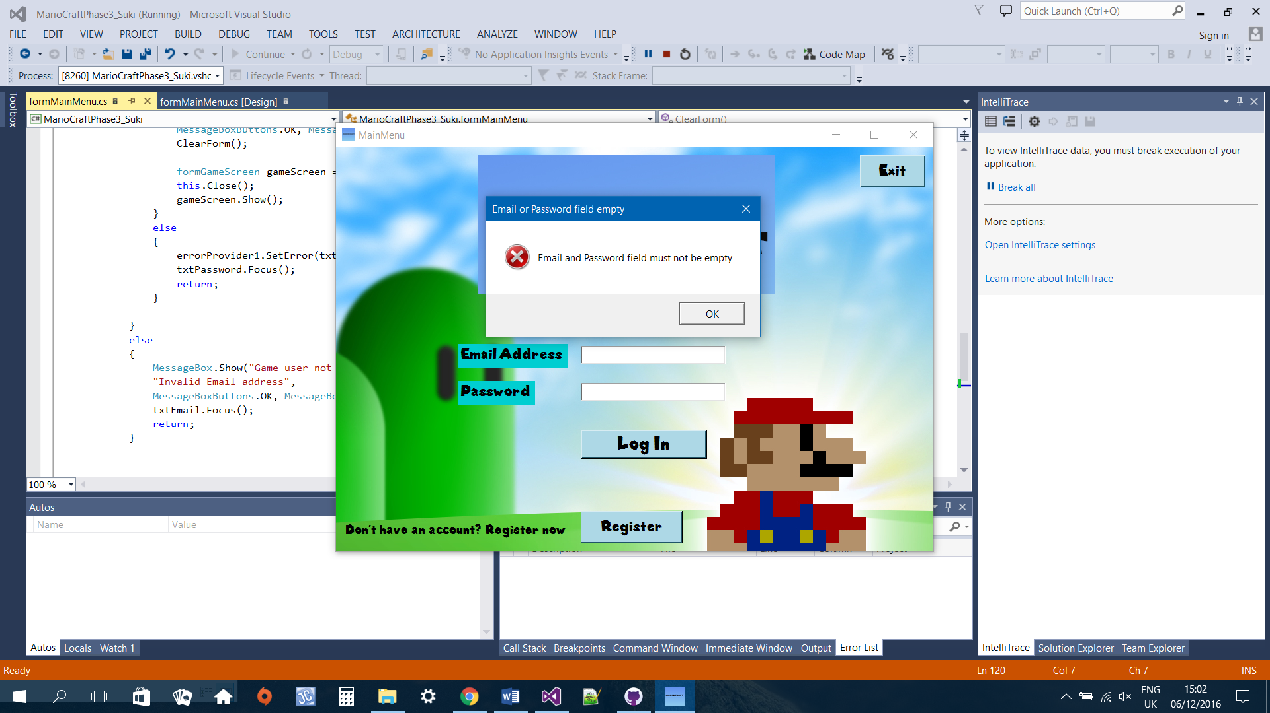

Email does not match database

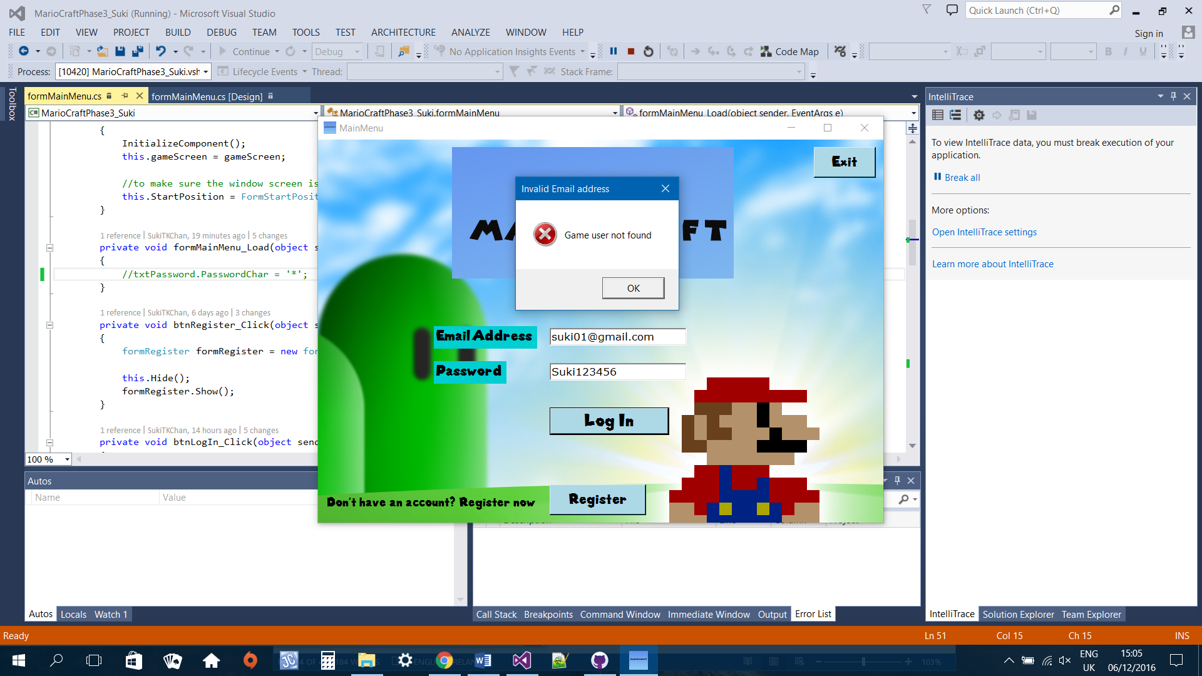

When valid email entered but password does not match database

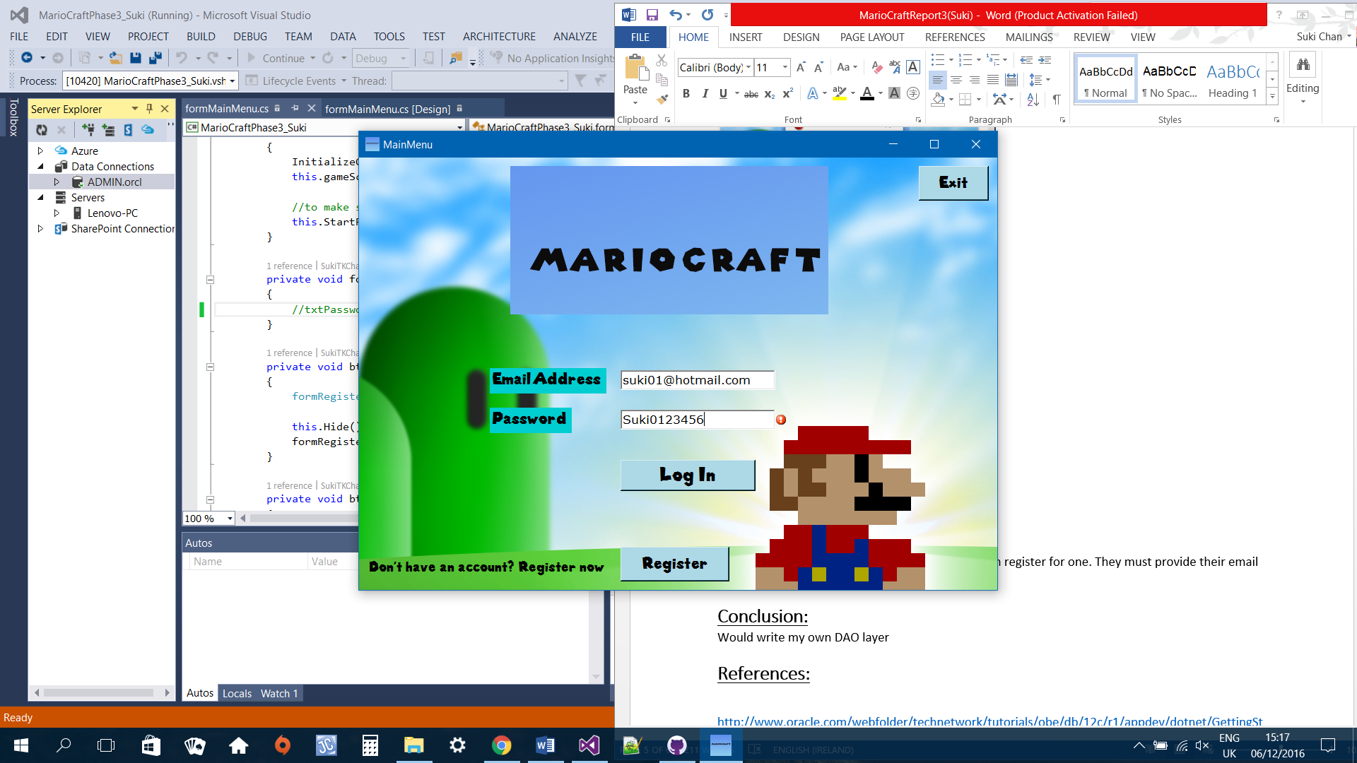

When both email and password matches database

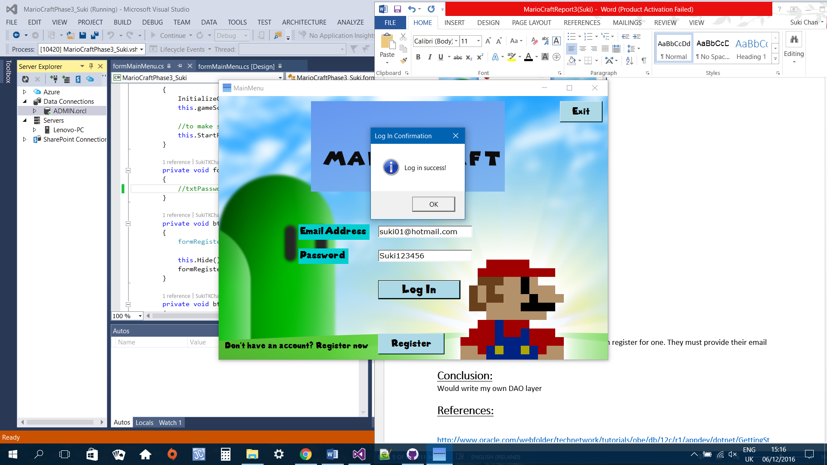

# **Register Form**

If the game user does not have an account, they can register for one. They must provide their email address and a password. The system will then check to make sure that the email enter does not already exists in the database because the constraint for email is it must be unique. If email matches database then the system will display the main menu where the game user can log in. Otherwise, the system will register the game user inserting email and password into database.

Code:

using System;

using System.Collections.Generic;

using System.ComponentModel;

using System.Data;

using System.Drawing;

using System.Linq;

using System.Text;

using System.Threading.Tasks;

using System.Windows.Forms;

namespace MarioCraftPhase3_Suki

{

public partial class formRegister : Form

{

private formMainMenu mainMenu;

public formRegister()

{

InitializeComponent();

}

public formRegister(formMainMenu mainMenu)

{

InitializeComponent();

this.mainMenu = mainMenu;

this.StartPosition = FormStartPosition.CenterScreen;

}

private void formRegister_Load(object sender, EventArgs e)

{

toolTipEmail.SetToolTip(txtEmail, "Email address must contains @ ");

toolTipPassword.SetToolTip(txtPassword, "Password must be at between 6-20 characters in length " +

"\nMust must contain a number " +

"\nAn uppercase and a lowercase ");

}

private void btnBack_Click(object sender, EventArgs e)

{

formMainMenu mainMenu = new formMainMenu(this);

this.Close();

mainMenu.Show();

}

private void btnSubmit_Click(object sender, EventArgs e)

{

MarioCraftModel ctx = new MarioCraftModel();

GAMEUSER addGameUser = new GAMEUSER();

var user = from u in ctx.GAMEUSERs where u.USEREMAIL == txtEmail.Text select u;

//check if user email matches database

var userExist = user.FirstOrDefault(a => a.USEREMAIL.Equals(txtEmail.Text));

//if either email or password field empty display error message

if (txtEmail.Text.Equals("") && txtPassword.Text.Equals(""))

{

MessageBox.Show("Email and Password field must not be empty", "Email or Password field empty",

MessageBoxButtons.OK, MessageBoxIcon.Error);

txtEmail.Focus();

return;

}

//if email does not match records in database

if (userExist != null)

{

//if password matches records in database

if (userExist.USERPASSWORD.Equals(txtPassword.Text))

{

MessageBox.Show("Game User already exist, please log in", "Registeration error",

MessageBoxButtons.OK, MessageBoxIcon.Error);

formMainMenu mainMenu = new formMainMenu(this);

this.Close();

mainMenu.Show();

}

}

else //insert user

{

using (var context = new MarioCraftModel())

{

addGameUser.USEREMAIL = txtEmail.Text;

addGameUser.USERPASSWORD = txtPassword.Text;

try

{

context.GAMEUSERs.Add(addGameUser);

context.SaveChanges();

MessageBox.Show(addGameUser.USEREMAIL + "\n" + addGameUser.USERPASSWORD + "\n" +

"You have Successfully Registered, Please log in", "Registered", MessageBoxButtons.OK, MessageBoxIcon.Information);

formMainMenu mainMenu = new formMainMenu(this);

this.Close();

mainMenu.Show();

ClearForm();

}

catch (Exception ex)

{

MessageBox.Show(ex.GetBaseException().ToString(), "Error", MessageBoxButtons.OK, MessageBoxIcon.Error);

}

}

}

}

private void ClearForm()

{

txtEmail.Clear();

txtPassword.Clear();

}

}

}

When email already exists

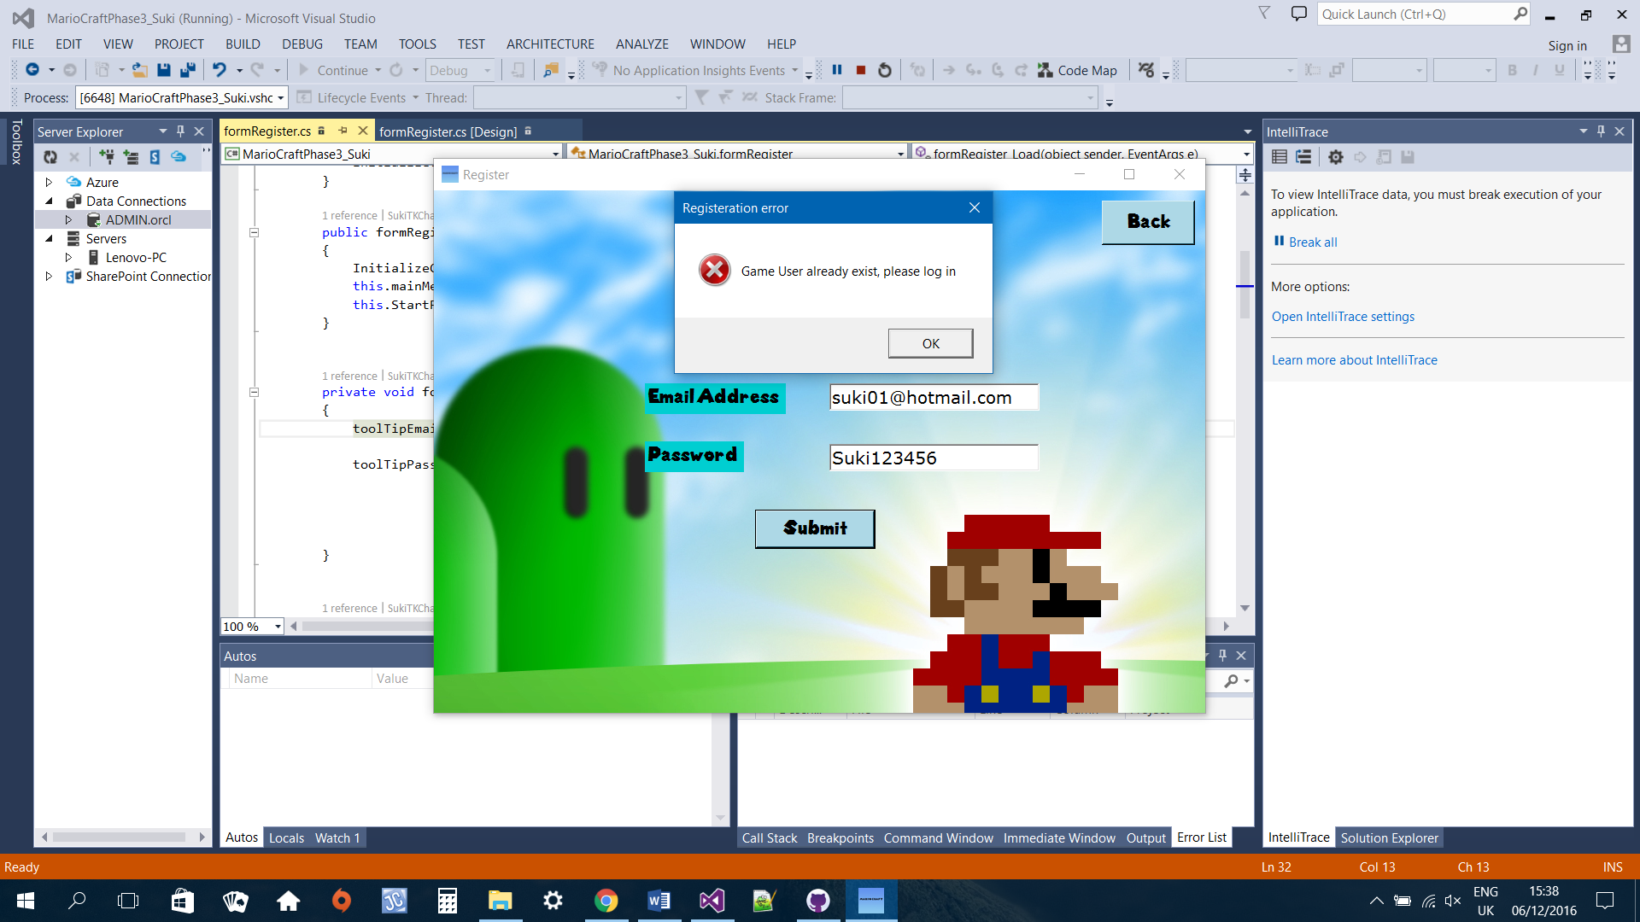

When both fields empty

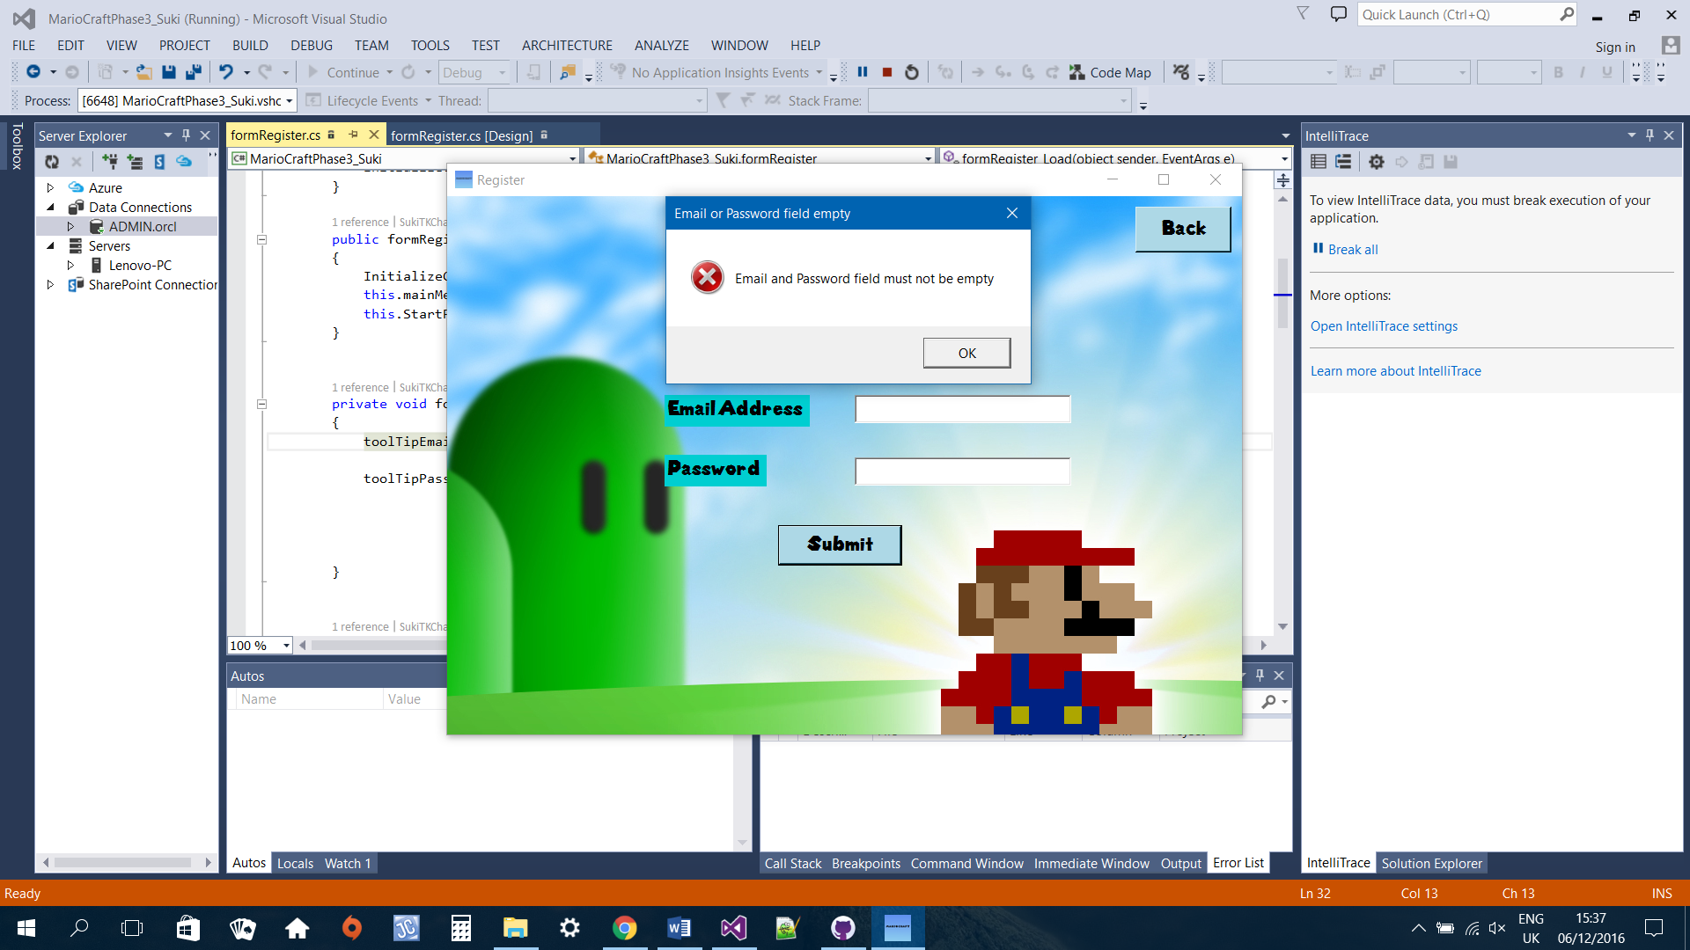

ToolTip

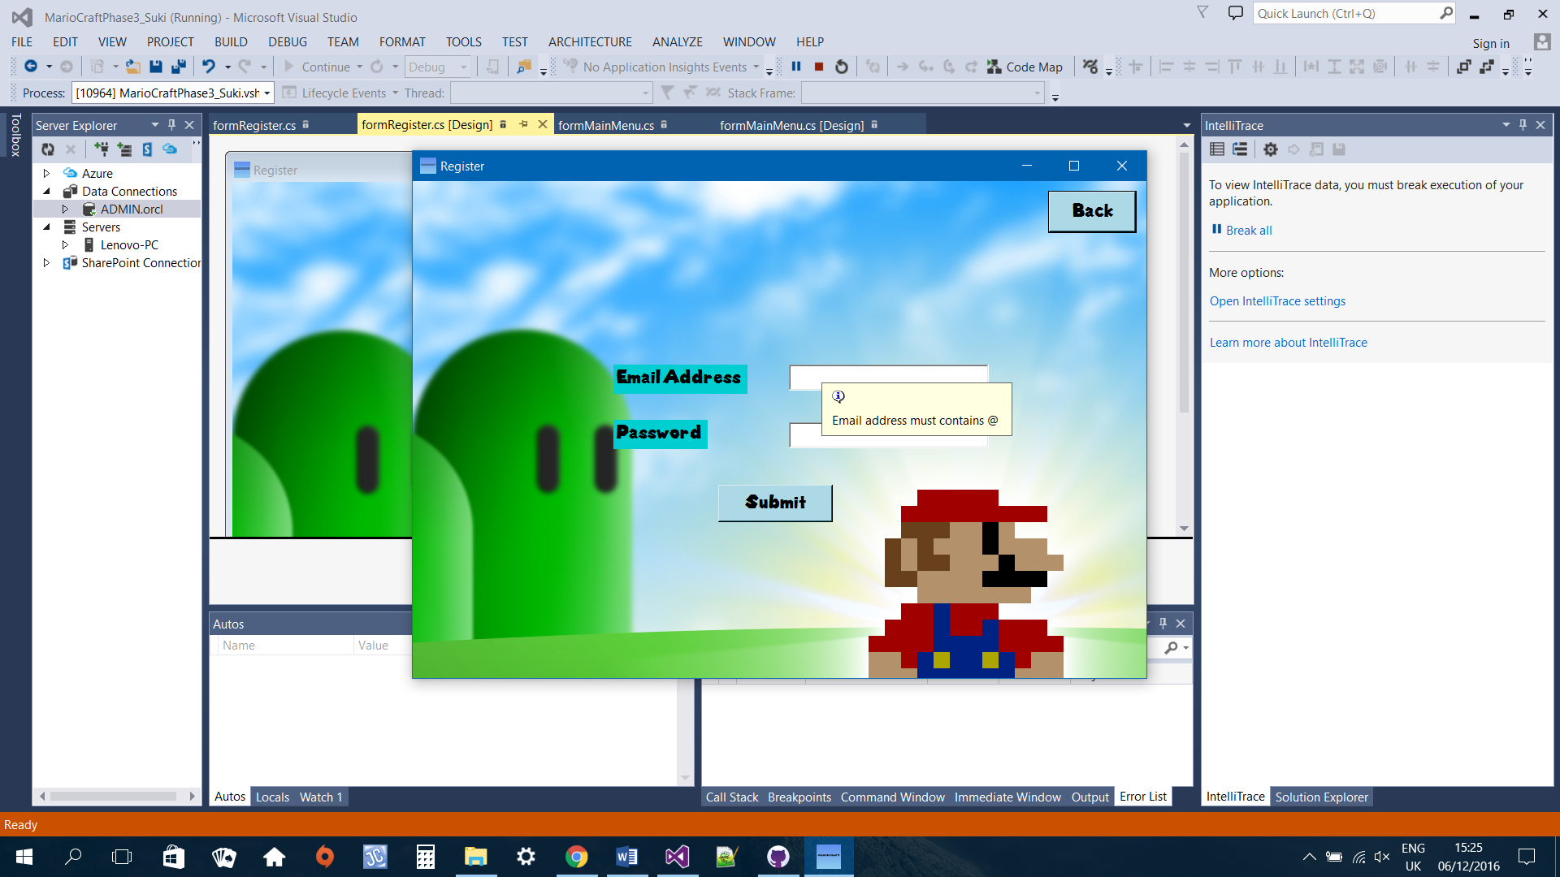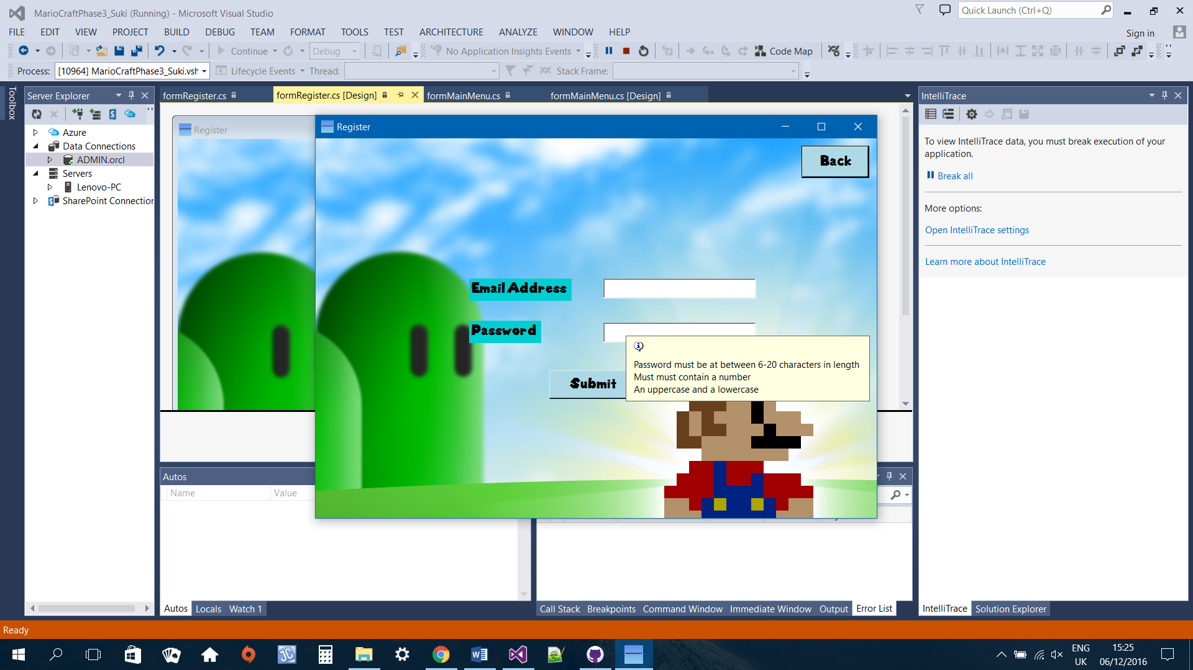

When

# **Conclusion**

Would write my own DAO layer

# **References**

<http://www.oracle.com/webfolder/technetwork/tutorials/obe/db/12c/r1/appdev/dotnet/GettingStartedNETVersion/index.html>

https://dotprogramming.blogspot.com/2015/09/login-form-using-entity-framework-in.html

<https://www.dotnetperls.com/errorprovider>

ToolTip <https://msdn.microsoft.com/en-us/library/aa984424(v=vs.71).aspx>

Player movement and Player Health:

<https://www.youtube.com/watch?v=2e-IJ1dAa28>

<https://www.youtube.com/watch?v=blBcGY_Ca7Q>

<https://www.youtube.com/watch?v=Cc62S6b94QQ>

Main Menu and Register Menu background image (Super mario bros pixelated backgrounds.): <http://www.pixelstalk.net/super-mario-backgrounds/>

Font [www.fontspace.com/category/mario](http://www.fontspace.com/category/mario) (Super Mario 286 by 538Fonts)